About Me
This page is all about me – Debbie Nicholson.
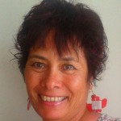
Hi there
My name is Debbie Nicholson and I am an author on Amazon in the Kindle Store as well as privately here on my own websites. The Internet opens up a whole new world to us if we want it to and I am excited to be part of this online experience.
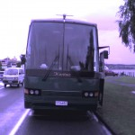
I work from home which is a mobile home and currently we are parked in a holiday park very close to the beach down under here in New Zealand.
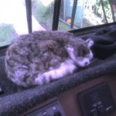
This is our cat who is very low maintenance and has a great story behind him. His name is Mr Chippy.
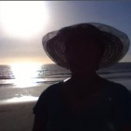
This is the lifestyle we are able to live with the help of online income.

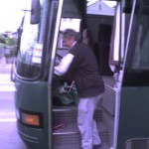
This is my darling husband Keith who still likes to work on call when someone calls him in to relieve workers when they want time off.
We have 3 children and 3 inlaw children. We have 9 grandchildren, and 1 Great Grandchild plus another one on the way in September.
I am a member of The Church Of Jesus Christ Of Latter Day Saints and this is a picture of our Temple in Hamilton where I like to spend 2 weeks of my time once a year for spiritual upliftment.
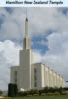
If you would like to know more about me then I encourage you to click on the links provided.
Kind regards
Debbie
Hyperlink
https://www.amazon.com/Debbie-Nicholson/e/B008Q4WNDE
Hyperlink
https://www.lds.org/?lang=eng

